Warehouse Visualizer

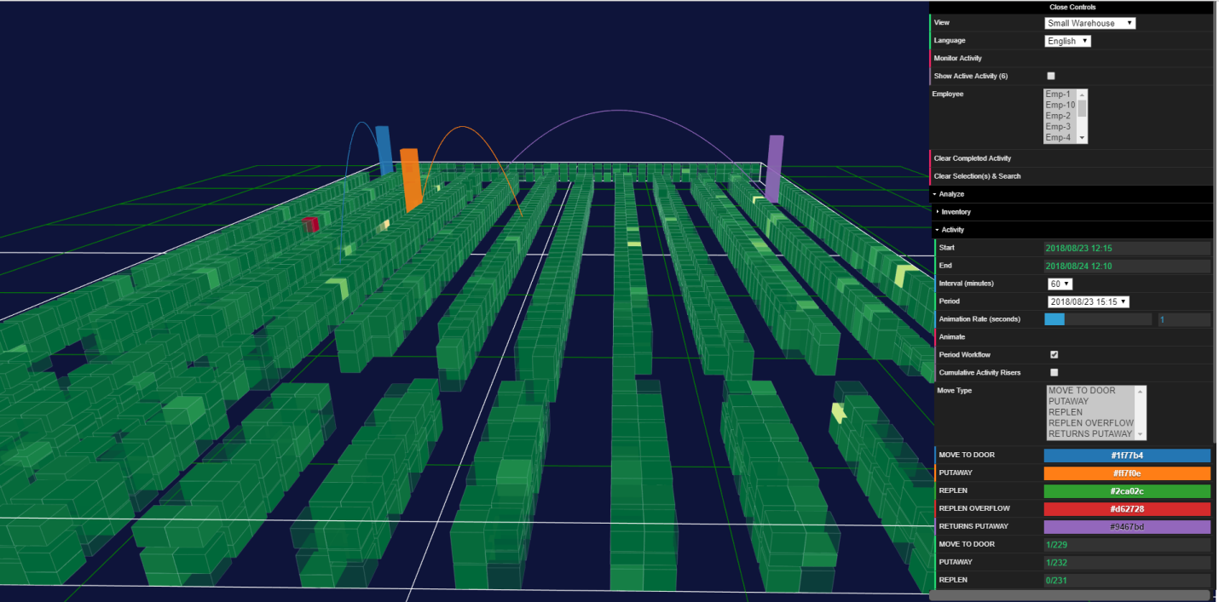

Table of Contents

Introduction 3

Application Architecture 6

warehouseVisualizer Folder 7

*css* Folder 7

*data* Folder 7

warehouses.txt File 8

activityData Folder 9

inventoryData Folder 11

layoutData Folder 12

*doc* Folder 15

*lib* Folder 15

Using the Warehouse Visualizer 16

Browser Support 16

Initiating the application 16

Active Activity 17

Analyze/Activity 19

Analyze/Inventory 22

Inventory Grid 23

# Introduction

The Warehouse Visualizer for (Visualizer) is a web-based application used to monitor, view and analyze:

* Current and historical Power Warehouse activity data;
* Slotted inventory data

Using a warehouse layout, activity and inventory data, an interactive, three-dimensional representation of a warehouse is rendered in a modern browser [supporting WebGL](https://get.webgl.org/). The specific development libraries used to develop the Visualizer are [Data-Driven Documents (D3)](https://d3js.org/) and [Three.js](https://threejs.org/).

The application can be used to display several warehouses layouts by a single user with data accessed in local computer file folders or as an application on a web server.

English and Spanish versions of the application are currently available. The application is designed to support other languages as well by adding translations to a translation file.

The Visualizer displays:

Current and Late Activity Workflows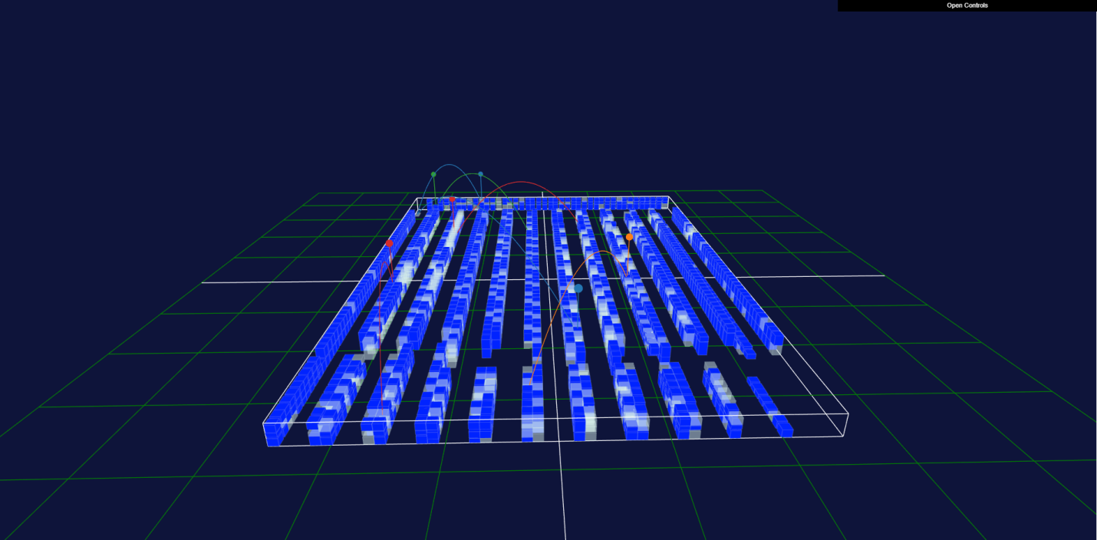

Animated Historical Activity Workflows  
  
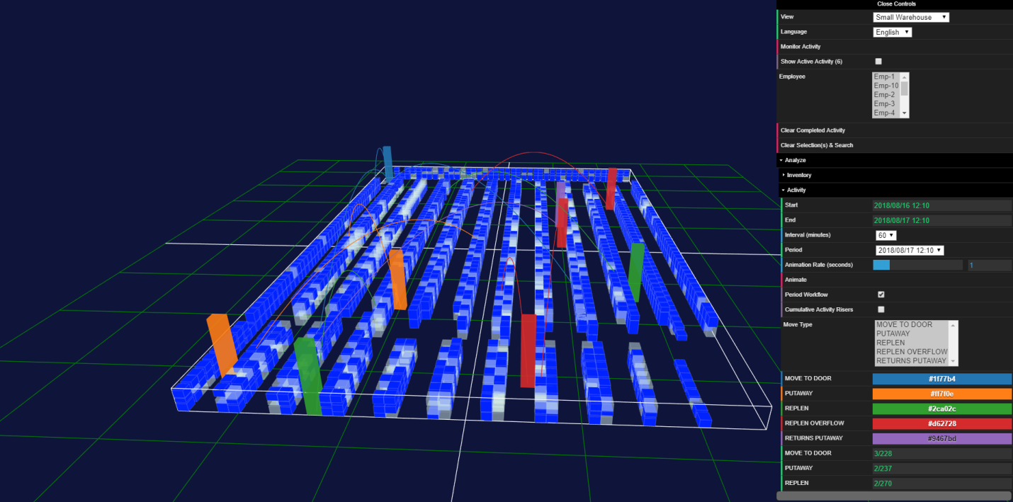

Stylized Inventory Analyses on Metrics and Dimensions  
  
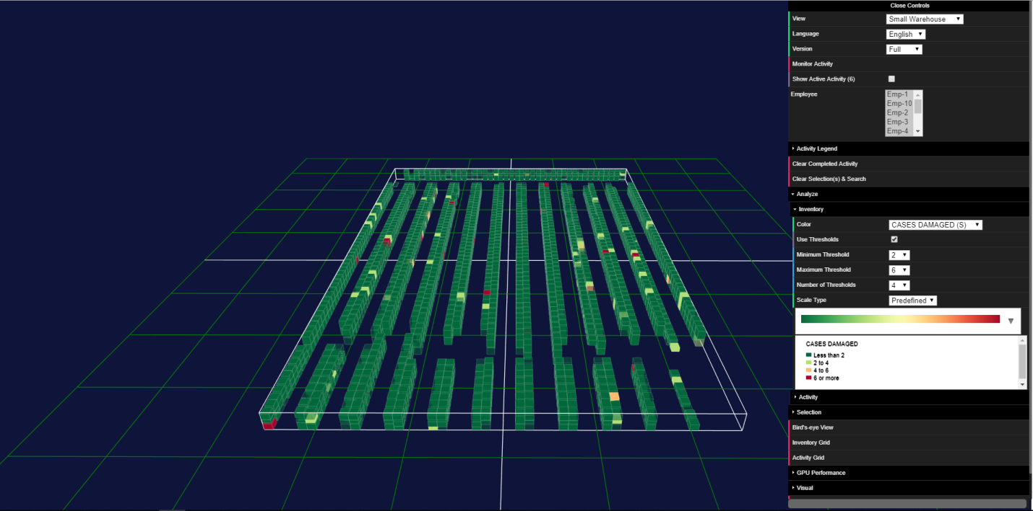

Inventory Isolation of Filtered Searches

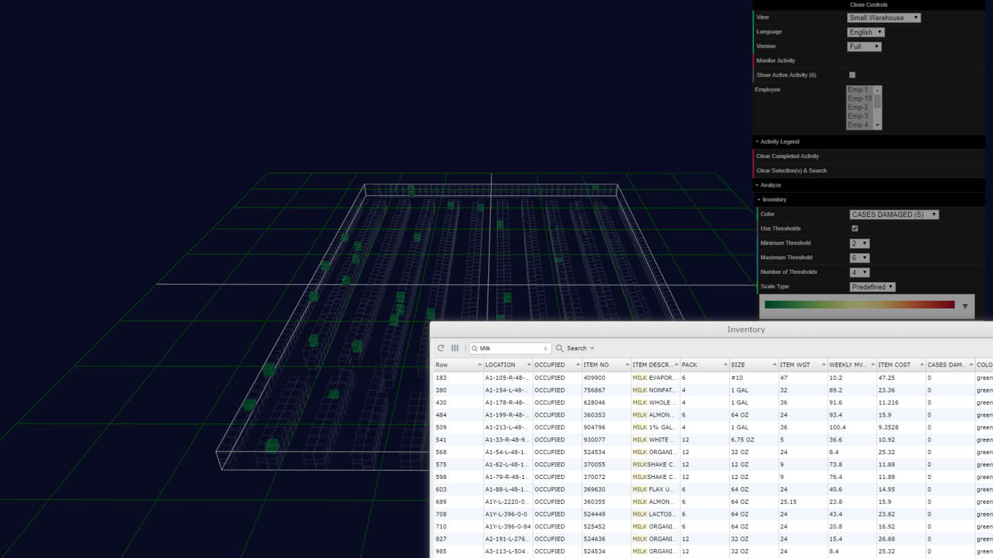

Customizable Links to Any Web Resource for Selected Items   
  
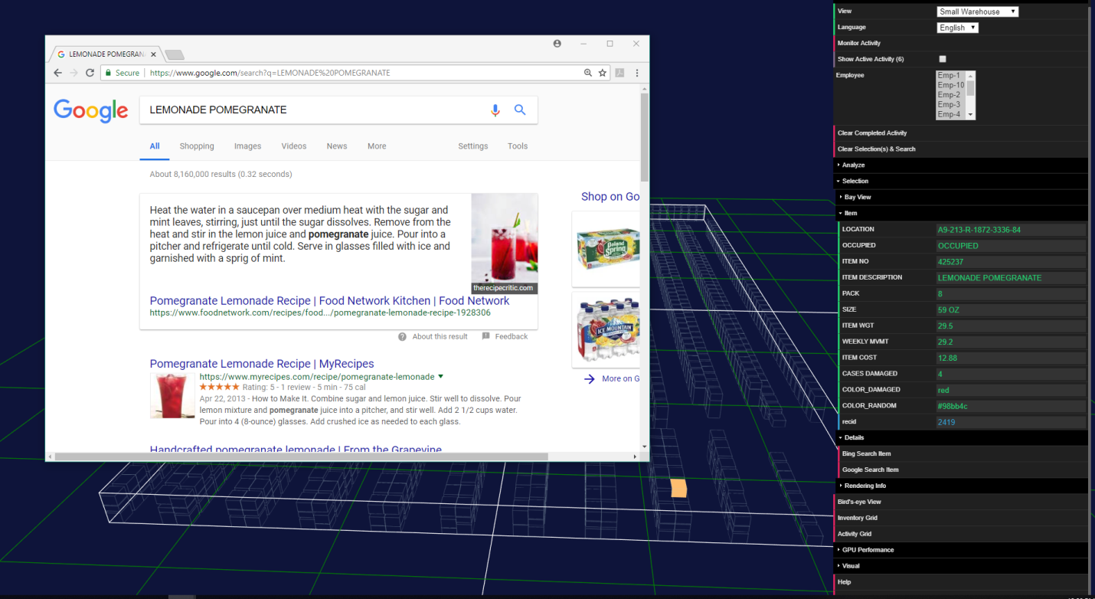

# Application Architecture

The Warehouse Visualizer’s file folder structure is represented by the following hierarchy:

## warehouseVisualizer Folder

The ***warehouseVisualizer*** folder is the root folder for the application. The launch web page for the application is the ***warehouseVisualizer.html*** web page.

### *css* Folder

[Cascading Style Sheet](https://en.wikipedia.org/wiki/Cascading_Style_Sheets) (CSS) files that are used by the application are located in the ***css*** folder.

### *data* Folder

The data folder is where the application’s data is located. The ***warehouses.txt*** file, located at the root of the data folder, along with several sub folders contain data specific to various functioning components of the application.

The format of the data files is [comma-separated value](https://en.wikipedia.org/wiki/Comma-separated_values) (CSV). The data are used by the Visualizer to render a three-dimensional warehouse on your device’s screen.

#### warehouses.txt File

The ***warehouses.txt*** file contains a comma separated list of warehouse names. For example, the following list describes the three demonstration warehouses included with the Visualizer; Small, Medium and Large:

Small, Medium, Large

The warehouse name(s) corresponds exactly (spelling and case with no preceding or trailing spaces) to the .csv data files in the ***activityData***, ***inventoryData*** and ***layoutData*** sub-folders.   
  
For example, a warehouse named ‘Large’ will have individual ‘Large.csv’ files in the ***activityData/completed***, **activityData/active**, **inventoryData** and **layoutData** folders; respectively for each type of data file.   
  
The warehouse names will be trimmed of leading and trailing spaces and will therefore reference data files without leading or trailing spaces in their respective file names. Referring to the demonstration file contents above, the ‘ Large’ warehouse is preceded with a space character that immediately follows the ‘,’ delimiter. However it will be used by the application to reference ‘Large.csv’ files and not ‘ Large.csv’ (with a prefixed space character) files.

#### activityData Folder

***activityData*** is a folder with ***completed*** and ***active*** activity data sub-folders. The data files are CSV-formatted.

Continuing with the ‘Large’ warehouse example, its corresponding completed activity file (***warehouseVisualizer/data/activityData/completed/Large.csv***) is represented by the following Excel screen shot with column descriptions:  
  
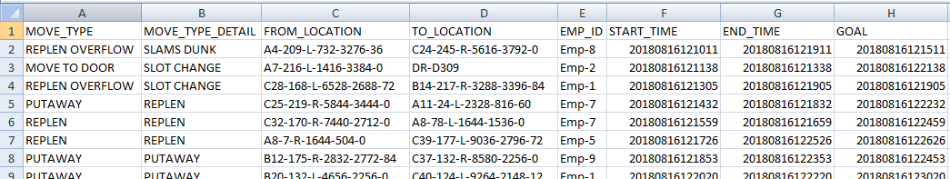

* **MOVE_TYPE**: The activity move type. The Visualizer supports up to ten unique move type descriptions.
* **MOVE_TYPE_DETAIL**: An optional column providing additional detail on the move type activity.
* **FROM_LOCATION**: The starting location of the move type activity. This location corresponds to the location identifier in the layout file discussed below.
* **TO_LOCATION**: The ending location for the move type activity. This location also corresponds to the location identifier in the layout file discussed below.
* **EMP_ID**: An employee identification number.
* **START_TIME**: A timestamp for the activity start time in YYYYMMDDHHMMSS character string format.
* **END_TIME**: A timestamp for the activity end time in YYYYMMDDHHMMSS character string format.
* **GOAL**: A timestamp for the activity goal time, when the activity was expected to be completed by, in YYYYMMDDHHMMSS character string format.

The corresponding active activity file for the ‘Large’ warehouse (***warehouseVisualizer/data/activityData/active/Large.csv***) is represented by the following Excel screen shot and the column descriptions:

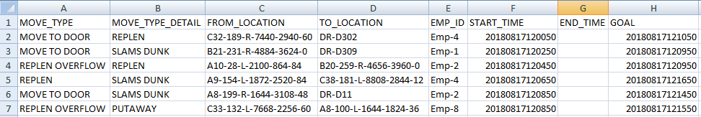

* **MOVE_TYPE**: The activity move type. The Visualizer supports up to ten unique move type descriptions.
* **MOVE_TYPE_DETAIL**: An optional column providing additional detail on the move type activity.
* **FROM_LOCATION**: The starting location of the move type activity. This location corresponds to the location identifier in the layout file discussed below.
* **TO_LOCATION**: The ending location for the move type activity. This location also corresponds to the location identifier in the layout file discussed below.
* **EMP_ID**: An employee identification number.
* **START_TIME**: A timestamp for the activity start time in YYYYMMDDHHMMSS character string format.
* **END_TIME**: This column is left blank in the active activity file because the activity has not completed. Once the activity is completed, it will be represented in the completed activity file discussed above.
* **GOAL**: A timestamp for the activity goal time, when the activity is expected to be completed by, in YYYYMMDDHHMMSS character string format.

Using both completed and active data, the Visualizer will graphically display information about the various activities:

* Completed activities can be visualized in Analyze/Activity discussed below.
* Active activities are visualized as either pending (non-flashing activity workflow indicators) or late (flashing activity workflow indicators) discussed below.

#### inventoryData Folder

***inventoryData*** folder contains slot inventory data sourced from a warehouse management system.

The following screenshot and column descriptions are for the ‘Large’ warehouse (***warehouseVisualizer/data/inventoryData/Large.csv***) example:

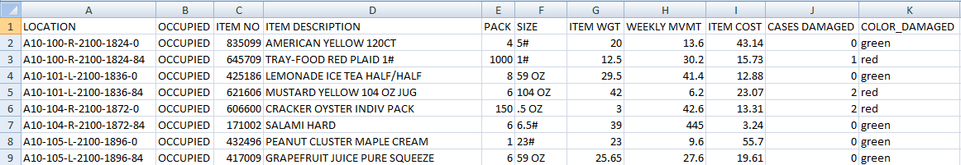

* **LOCATION**: This column is a required column in the inventory data file and corresponds to a slot LOCATION column in the layout data file discussed below.
* **OCCUPIED**: OCCUPIED is a required column and specifies whether-or-not a given LOCATION slot is occupied. Acceptable values are ‘OCCUPIED’, ‘EMPTY’, 1,0; where 1 denotes occupied and 0 denotes empty.
* **ITEM NO, ITEM DESCRIPTION, PACK,SIZE, ITEM WGT, WEEKLY MVMT, ITEM COST, CASES DAMAGED**: These columns are optional columns in the inventory file and are attributes associated with the inventory stored at a given slot location.
* **COLOR_DAMAGED**: This column is a custom (C) color column using CSS Color Names as described at <https://www.w3schools.com/cssref/css_colors.asp> . A column with a prefix of ‘COLOR_’ will be interpreted by the application as a custom color for visualization purposes in the Analyze/Inventory tool of the Visualizer discussed below.

The application will support a total of 20 optional and custom color columns in any combination, in addition to the two required columns of **LOCATION** and **OCCUPIED**. Column names should just use simple text letters and no special characters other than space (‘ ‘), hyphen (‘-‘) and underscore (‘_’).

#### layoutData Folder

The **layoutData** folder contains the data file with the spatial (x,y and z coordinates), dimensional (length, width and height metrics) and management attributes (location, aisle, aisle side, bay, center axis) that represent a warehouse. Typically, these attributes are available from a warehouse management system.

This is a screenshot for a few of the slots in the ‘Large’ warehouse (***warehouseVisualizer/data/layoutData/Large.csv***) as represented when the file is loaded into Excel (all dimensional values are in [Imperial inches](https://en.wikipedia.org/wiki/Inch)):

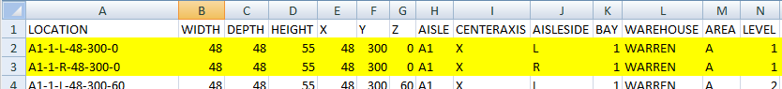

* **LOCATION**: This column is required. It corresponds to a slot LOCATION and uniquely identifies it.
* **WIDTH**: This column is required. It represents the width (Imperial or Metric units) parallel to the aisle’s centerline.
* **DEPTH**: This column is required. It represents the depth (Imperial or Metric units) perpendicular to the aisle’s centerline.
* **HEIGHT**: This column is required. It represents the height (Imperial or Metric units) perpendicular to the aisle’s centerline and the X,Y plane.
* **X,Y,Z**: These columns are required. They represent the center location of a slot, centered on its aisle centerline. See example below for more details.
* **CENTERAXIS**: This column is required. It instructs the application on the aisle orientation. See example below for more details.
* **AISLESIDE**: This column is required. It instructs the application to render the slot on either the left or right side of an aisle relative the aisles orientation (determined by the **CENTERAXIS**) and the **X,Y,Z** origin for the warehouse.
* **AISLE**: This column is required. It is the unique aisle identifier.
* **BAY**: This column is required. It is the unique bay identifier. A bay is a grouping adjacent slots.
* **WAREHOUSE, AREA, LEVEL**: These are optional attributes that provide additional details for a given slot. The application can reference up to 20 additional attributes for a slot.

The spatial coordinates are aisle centered along an aisle’s center line. The Visualizer is configured with a customizable attribute that will assign the warehouse’s aisle width (edge-to-edge) relative to the slots (**aisleWidthEdgeToEdge**).

Two slots (LOCATIONS A1-1-L-48-300-0 and A1-1-R-48-300-0) from the ‘Large’ warehouse will be referenced to illustrate a specific example:



The details and diagrams that follow explain how the two slots are displayed in the application:

* The slots are at the same relative distance from the origin along the Y axis (300) and relative distance from the floor of the warehouse (the XY plane) with a Z value of 0.
* Each slot has the exact same X coordinate value (48) at their respective centers. This represents the slots’ X coordinate being ‘centered’ with respect to the aisle’s center line. The application calculates the relative WebGL display locations of the slot along the X axis using the **CENTERAXIS** (X), **AISLESIDE (**L or R**),** the **WIDTH** (48) and the customizable **aisleWidthEdgeToEdge** attribute; 132 for all the sample warehouses. Similar logic is used to display slots when they have a ‘Y’ value for the **CENTERAXIS.**

aisleWidthEdgeToEdge

Aisle CENTERAXIS: X  
(Determined to be a value of 48 from the slot coordinates)

(0,0,0) (x,y,z) The z axis is coming out of the diagram. The HEIGHT dimension is along the Z axis.

Y

X

Left side of aisle relative to (0,0,0) origin

Right side of aisle relative to (0,0,0) origin



Slot:  
A1-1-L-48-300-0

WIDTH

DEPTH

Slot coordinates  
 (48, 300, 0) at center

Slot:   
A1-1-R-48-300-0

Slot coordinates   
(48, 300, 0) at center

WebGL Scene Display Coordinates:

aisleWidthEdgeToEdge

Aisle CENTERAXIS: X

Z

X

Slot:  
A1-1-L-48-300-0

WIDTH

DEPTH

Display coordinates (138, 28, 300) at center

Slot:   
A1-1-R-48-300-0

Display coordinates   
(-42, 28, 300) at center

(0,0,0) (x,y,z) The y axis is coming out of the diagram

The Y axis (relative to the warehouse in the physical ‘world space’) is now referred to as the Z axis in the [WebGL ‘screen space’](https://learnopengl.com/Getting-started/Coordinate-Systems). A ‘scene’ is a [WebGL](https://webglfundamentals.org/webgl/lessons/webgl-scene-graph.html) and [Three.js](https://threejs.org/docs/index.html#manual/introduction/Creating-a-scene) concept representing the visual objects being rendered by the programming logic.

The values of -42 and 138 for the display ‘scene’ calculated X coordinates were calculated with the following logic:

sceneX = (slot’s X coordinate) - ((aisleWidthEdgeToEdge + slot’s WIDTH) / 2); for right-sided slots  
 = (48) – ((132 + 48)/2)  
 = -42

sceneX = (slot’s X coordinate) + ((aisleWidthEdgeToEdge + slot’s WIDTH) / 2); for left-sided slots  
 = (48) + ((132 + 48)/2)  
 = 138

The sceneX values of -42 and 138 are relative display values to the display device’s center and not the warehouse’s origin. This also accounts for ‘scene’ Y center value of 28 for each of the slots which have HEIGHT values of 55.

The **aisleWidthEdgeToEdge** attribute is assigned as a property of the Visualizer in the programming code as noted in the following code snippet from the ***warehouseVisualizer.html*** web page:

var objWarehouse = {  
 ...  
 aisleWidthEdgeToEdge: (12 * 11), //Aisle distance, from slot edges  
 ...  
 };

//INSTANTIATE NEW VISUAL WITH OPTIONS  
visualWarehouse = new warehouse(objWarehouse);

### *doc* Folder

This document and other related documentation files are located in the ***doc*** folder.

### *lib* Folder

The ***lib*** folder contains is the program library for the application which contains the JavaScript (.js) files.

# Using the Warehouse Visualizer

## Browser Support

The Warehouse Visualizer was developed using Google Chrome Version 68.0.3440.106. Limited testing has been done for [FireFox and Microsoft Edge browsers that support WebGL](https://www.caniuse.com/#feat=webgl).

## Initiating the application

The application can be initiated in your browser using local file access or by referencing it as an application hosted on a web server.

For local file access, the browser url format is:

file:///[Drive]:/[parentFolder]/warehouseVisualizer/warehouseVisualizer.html

For web server access, the browser url format is:

http[s]:[port]//warehouseVisualizer/warehouseVisualizer.html

Both syntax formats assume the application is in a ***warehouseVisualizer*** folder that can be referenced by the browser; either through the file system or web server.

Google Chrome allows for local file access when it is started with an **--allow-file-access-from-files** option as detailed in the article [***How to set the allow-file-access-from-files flag option in Google Chrome***](http://chrome-allow-file-access-from-file.com/)***:***

On Windows Operating System

1. Get the url of your Chrome Installation path to your chrome installation e.g C:\Users\-your-user-name\AppData\Local\Google\Chrome\Application>
2. Launch the Google Chrome browser from the command line window with the additional argument ‘–allow-file-access-from-files’. E.g ‘path to your chrome installation\chrome.exe --allow-file-access-from-files’
3. Temporary method you can use each time you are testing  
   - Copy the existing chrome launcher  
   - Do as above and save it with a new name e.g chrome – testing  
   - Alternatively, you can simply create a new launcher with the above and use it to start chrome.

## Active Activity

The Visualizer initial view for a warehouse is the Active Activity view:

* Activity that is scheduled and still within its goal period will display as initiating from a location with a non-blinking workflow indicator to the targeted locations. In the following screen shot:
  + The red colored push-pin indicates the starting point of a REPLEN OVERFLOW activity. The detail information in the control area is displayed by double-click selecting the head of the push-pin.  
      
    The same control area shows that there are a total of six (6) active activities; zero (0) of them are late;
  + The activity was scheduled to start at 11:59:30 AM and should be completed by 12:09:30 PM to be considered on-time.   
      
    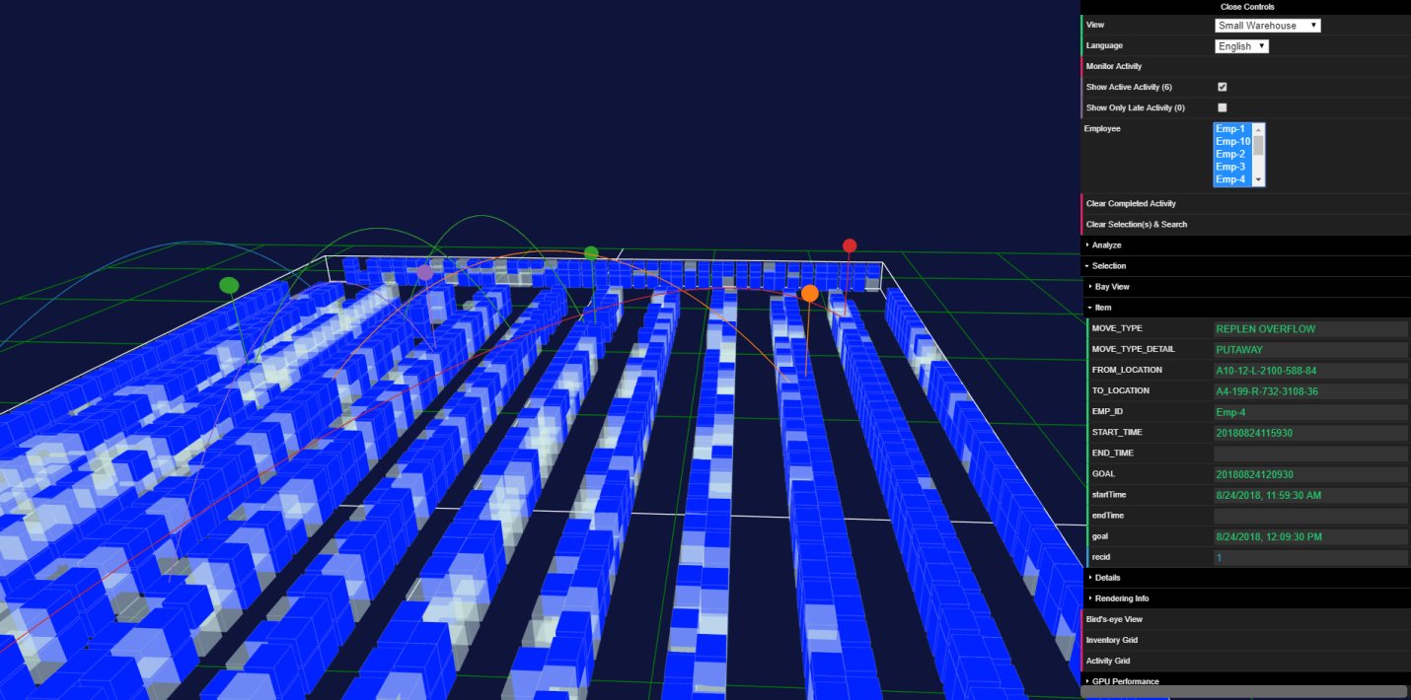
  + The next screen illustrates that the same activity at 12:14 PM. Note that the workflow indicator is blinking as the screen shot was made as it went into the ‘hide’ indicator state as part of its blinking screen interaction. In fact, another activity in the same aisle is also being indicated as being late and not meeting its goal.   
      
    All together, the control area notes that at 12:14 PM, four (4) of the activities in the first screen shot are now late. The two activities that are still within their goal periods are displayed with solid workflow indicators.  
      
    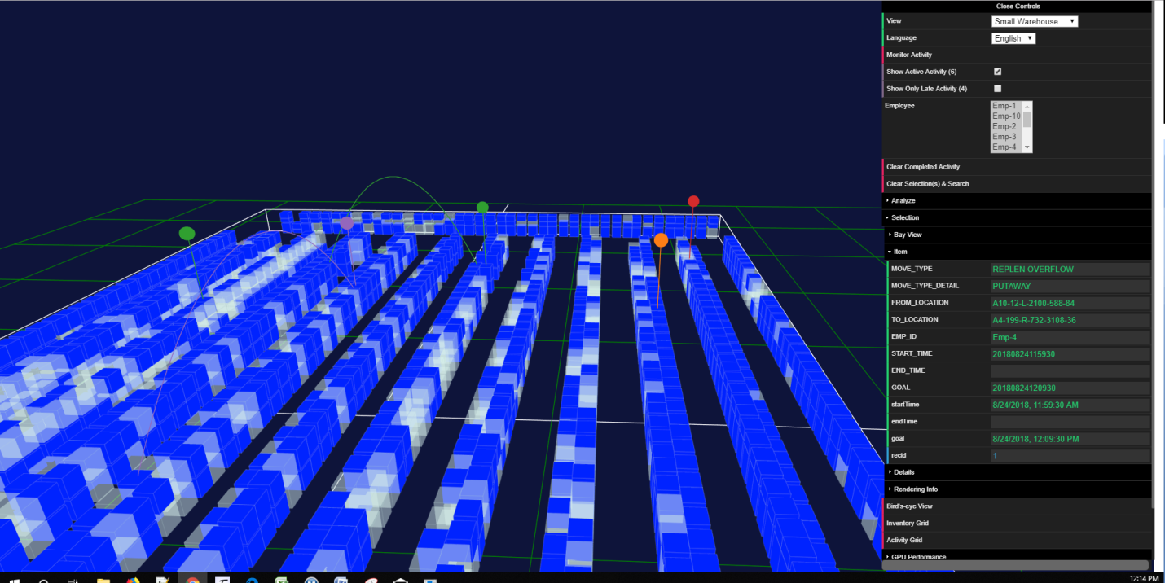
  + The activities can be further filtered with the ‘Employee’ multi-select drop down in the control area. The employee filtering also applies to the *Analyze/Activity* feature discussed below.

## Analyze/Activity

Expanding the *Analyze/Activity* option on the control area displays a completed activity view:  
  
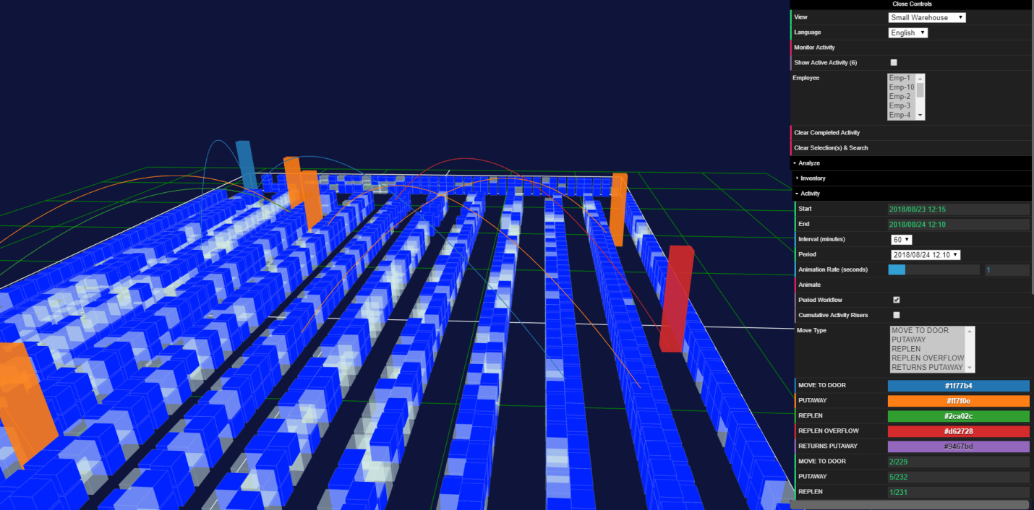

Each colored riser represents that relative level of activity for a storage bay, adjacent to the riser, for the filtered period and employees.

Double-click selecting a specific riser displays details on all the bay’s activities and activates the *Analyze/Selection/Item* control area. This area provides specific details on the selected riser. Note that an individual bay can have multiple types of activities, each of which is detailed in this view:

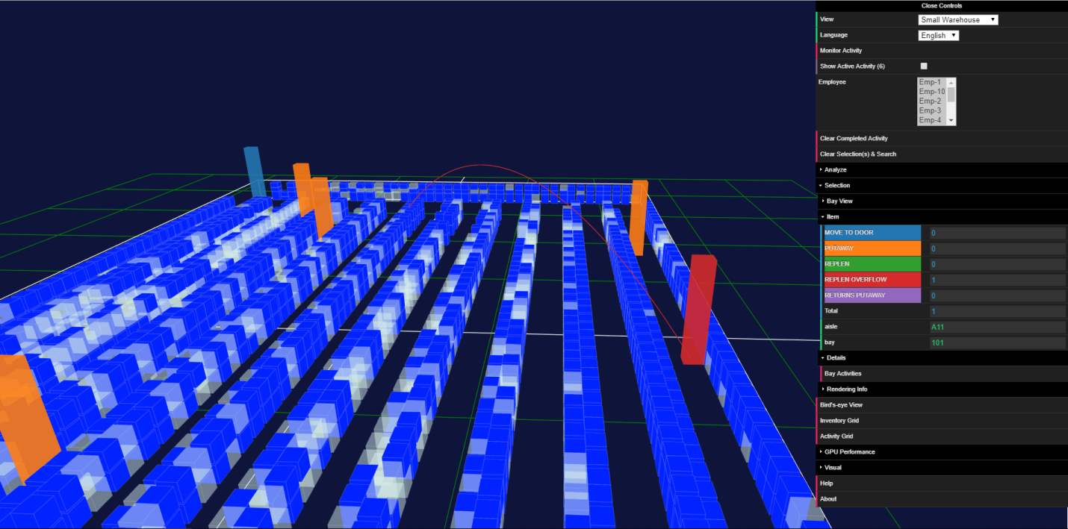

Selecting the *Analyze/Selection/Bay Activities* option displays a data grid of the relevant activity from the completed activity file:  
  
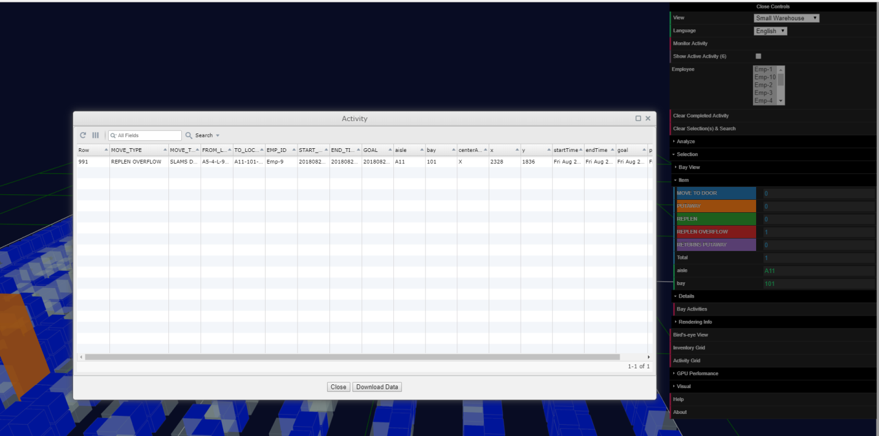

The completed activity can be animated by selecting the *Analyze/Activity/Animate*. Selecting the *Cumulative Activity Risers* displays all accumulated activity for the enabled filters:

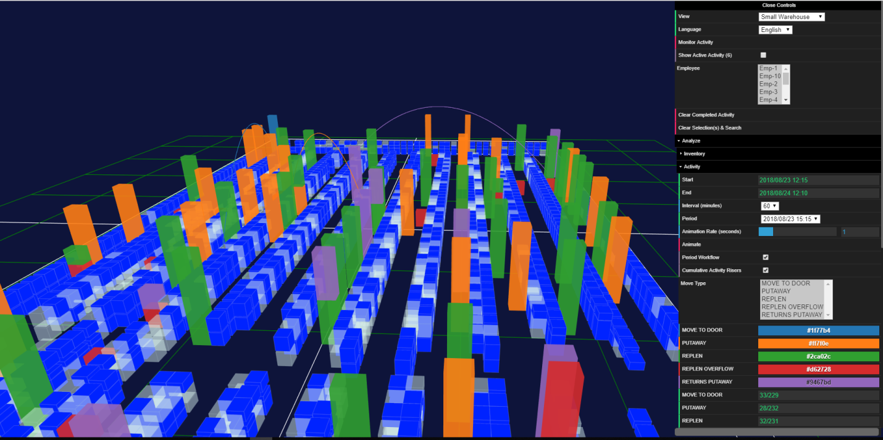

## Analyze/Inventory

The *Analyze/Inventory* feature in the control area utilizes inventory data to dynamically create powerful visualizations. The screen shot below utilizes the ‘COLOR_DAMAGED’ ( DAMAGED (C) ) custom color that was pre-calculated in the inventory data to display which slots have damaged inventory:

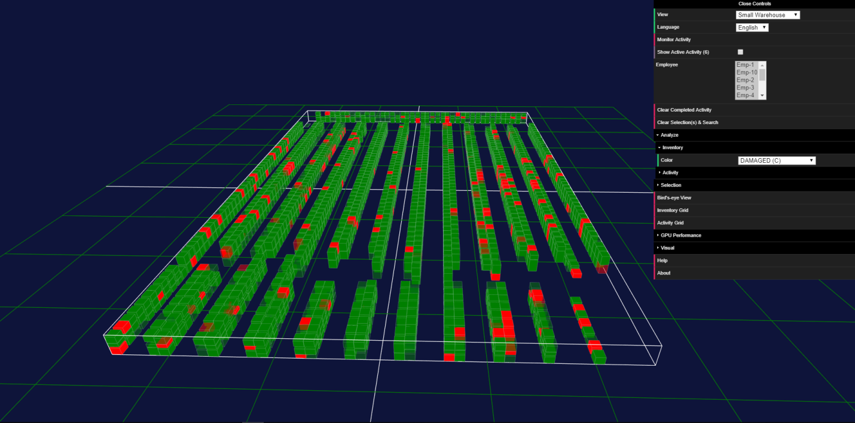

The screen shot below is an example of a similar damage analysis, but it utilizes a pre-defined color scale (green is low damage counts, red is high damage counts) and metric thresholds (Minimum Threshold is 2, Maximum Threshold is 13, Number of Threshold Intervals is 4):  
  


## Inventory Grid

The *Inventory Grid* is used to filter the display of slots that match a search criterion. The screen shots below show a filter on all products starting with ‘Milk’ in their description with the ‘DAMAGED (C)’ visualization being applied.

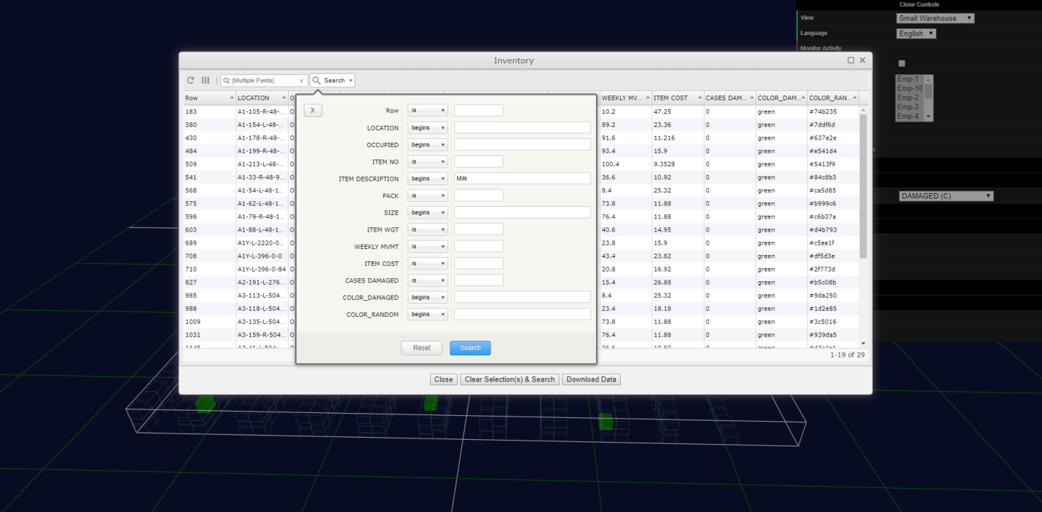

None of the filtered slots that have ‘Milk’ related products have damage associated with them in the inventory data file:

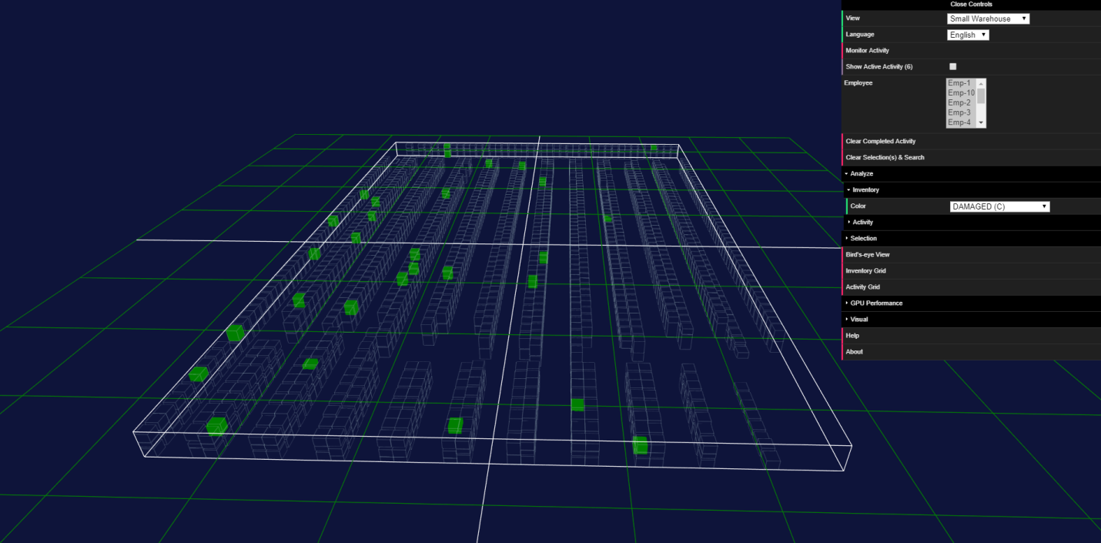

Double-click selecting any bay that has a search-related inventory item will display the specific slot that is in the search criterion in the *Analyze/Item* view:  
  
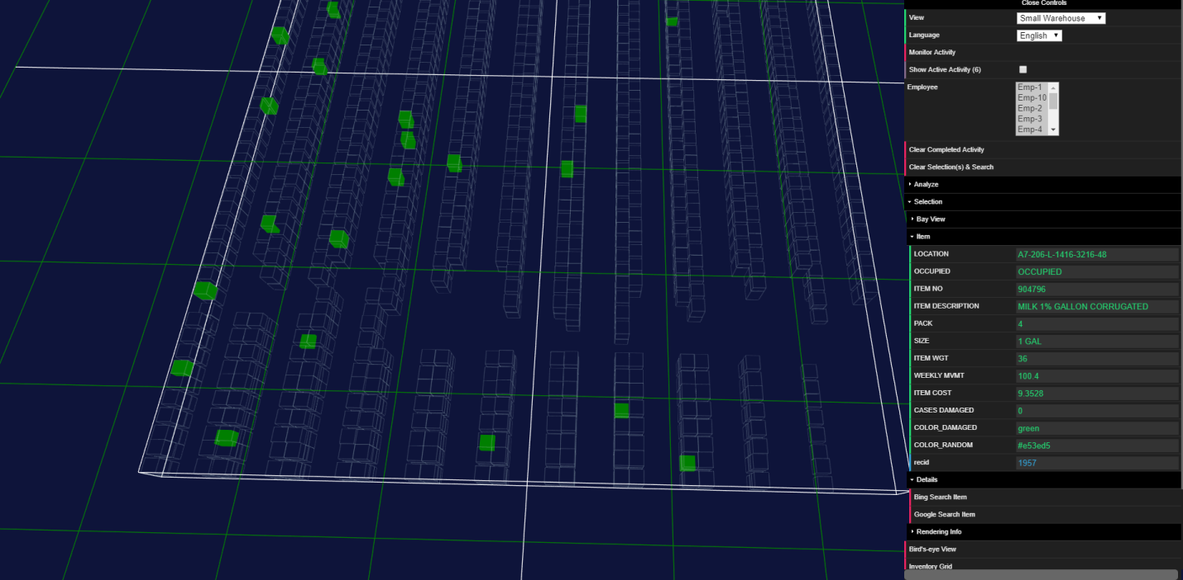

To see details on the slots in the same bay as the item in the search criterion, use the *Analyze/Selection/Bay View* and double-click the slots located in the same bay:

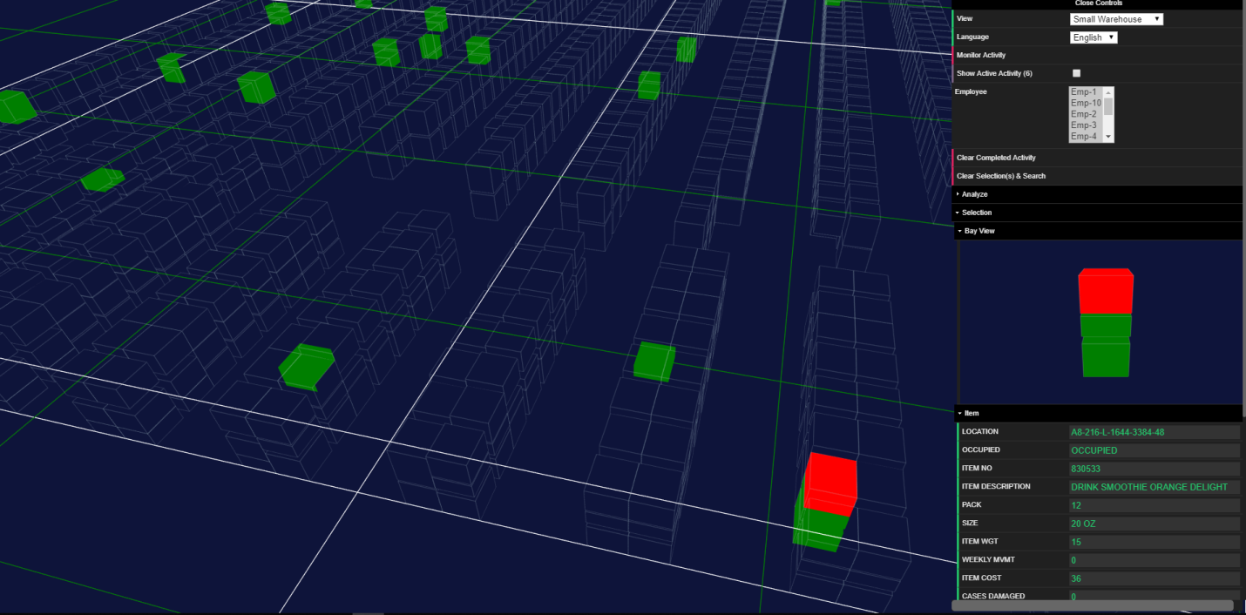

If *Details* have been programmed for the selections, they can be viewed by selecting their respective options in the *Analyze/Selection/Item view.*These screen shots show what happens when the damaged ‘DRINK SMOOTHIE GREEN MEGA’ *Bing Search Item* option is selected:   
  
